Specification Sheet

The Connecticut Stamping & Bending Company
Slip Joint Dishwasher Branch Tailpieces w/ ¾" Hose Clamp

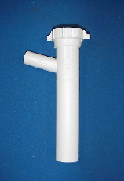
Part Number | Size | Color | Material
58558WR | 1 ½ x 8 ¾" | White | Poly-Pro
68558WR | 1 ½ x 8 ¾" | Black | Poly-Pro

Tel: (860) 225-4637, Fax: (860) 229-4328

Toll Free: 1-800-966-6964, E-mail: sales@macristy.com

206 Newington Avenue, P.O. Box 2380

New Britain, CT 06050

