
Specification Sheet

C.S.B. INTERNATIONAL PRODUCTS INC.

1 ¼" Double Offsets

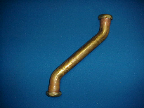

Tel: (860) 263-3635, Fax: (860) 229-4328

E-mail: sales@csbint.biz

41 Hammer Hill Road,
Rocky Hill, CT 06067

Part Number | Size | Finish | Material
667CP | 1 ¼ x 12" 22GA | Chrome Plated | Brass
667RB | 1 ¼ x 12" 22GA | Rough Brass | Brass
4667CP | 1 ¼ x 12" 17GA | Chrome Plated | Brass
4667RB | 1 ¼ x 12" 17GA | Rough Brass | Brass

