
Specification Sheet

C.S.B. INTERNATIONAL PRODUCTS INC.

1 ½" Double Offsets

Part Number | Size | Finish | Material
668CP | 1 ½ x 12" 22GA | Chrome Plated | Brass
668RB | 1 ½ x 12" 22GA | Rough Brass | Brass
4668CP | 1 ½ x 12" 17GA | Chrome Plated | Brass
4668RB | 1 ½ x 12" 17GA | Rough Brass | Brass

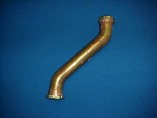

Tel: (860) 263-3635, Fax: (860) 229-4328

E-mail: sales@csbint.biz

41 Hammer Hill Road,
Rocky Hill, CT 06067

