
Specification Sheet

C.S.B. INTERNATIONAL PRODUCTS INC.

1 ¼" One Piece C.O. Plug One Piece Less Overflow

Part Number | Size | Finish | Material
689-5PC | 1 ¼ x 5" 22GA | Polished Chrome | Brass

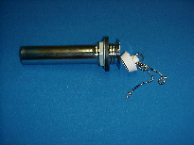

Tel: (860) 263-3635, Fax: (860) 229-4328

E-mail: sales@csbint.biz

41 Hammer Hill Road,
Rocky Hill, CT 06067

