
Specification Sheet

C.S.B. INTERNATIONAL PRODUCTS INC.

1 ¼" Two Piece P.O. Plugs

Part Number | O.D. x Dim "A" | Finish | Material
696-5PC | 1 ¼ x 5" 22GA | Polished Chrome | Brass
696-6PC | 1 ¼ x 6" 22GA | Polished Chrome | Brass
696-8PC | 1 ¼ x 8" 22GA | Polished Chrome | Brass
696-12PC | 1 ¼ x 12" 22GA | Polished Chrome | Brass
700-8PC | 1 ¼ x 8" 17GA | Polished Chrome | Brass
17 GA P.O. Plugs Available In The Same Lengths As 22 GA, Add Appropriate Suffix To Part No.
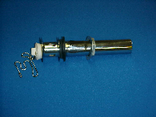

Tel: (860) 263-3635, Fax: (860) 229-4328

E-mail: sales@csbint.biz

41 Hammer Hill Road,
Rocky Hill, CT 06067

