
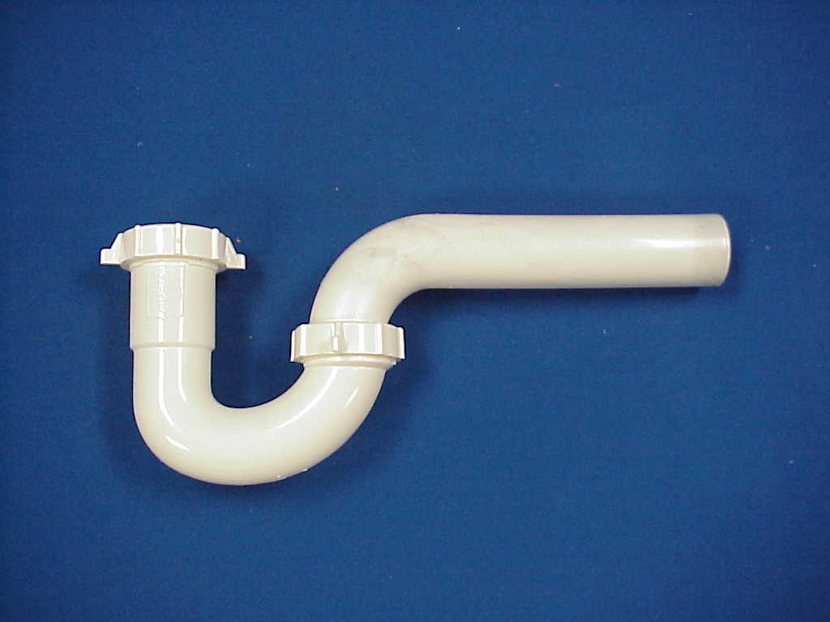Specification Sheet

C.S.B. INTERNATIONAL PRODUCTS INC.

1 ¼" P-Traps

Part Number | Size | Color | Material
711LA | 1 ¼" | White | Poly-Pro

Tel: (860) 263-3635, Fax: (860) 229-4328

E-mail: sales@csbint.biz

41 Hammer Hill Road,
Rocky Hill, CT 06067

