
Specification Sheet

C.S.B. INTERNATIONAL PRODUCTS INC.

Basket w/Rolled Edge & Stick Post, Easy Mount Thumb Screw Plate

Part Number | Size | Material
724SS | 3 ½ - 4" | Stainless Steel

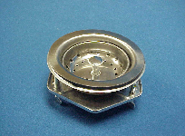

Tel: (860) 263-3635, Fax: (860) 229-4328

E-mail: sales@csbint.biz

41 Hammer Hill Road,
Rocky Hill, CT 06067

