
Specification Sheet

C.S.B. INTERNATIONAL PRODUCTS INC.

Duo Strainer, Stainless Steel Basket w/Rolled-Edge & Stick Post, ¼" Rubber Washer, Fiber Washer & Die Cast Lock Nut

Part Number | Size | Lock Nut | Material
725PC | 3 ½"-4" | 3 38" Heavy | Brass Body
725SS | 3 ½"-4" | 3 3/8" | All Stainless Steel

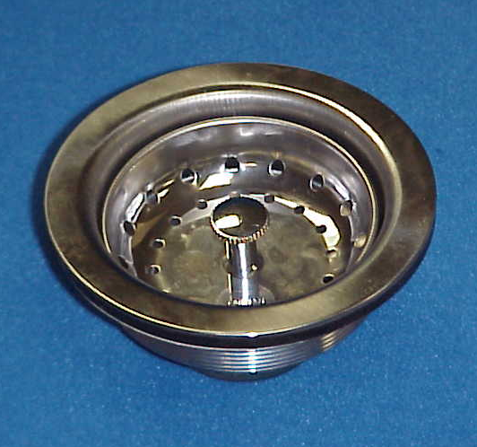

Tel: (860) 263-3635, Fax: (860) 229-4328

E-mail: sales@csbint.biz

41 Hammer Hill Road,
Rocky Hill, CT 06067

