
Specification Sheet

C.S.B. INTERNATIONAL PRODUCTS INC.

Stainless Steel Basket w/Stick Post, 4" Chrome Plated Tailpiece, ¼" Rubber Washer, Fiber Washer, 3 3/8" Heavy Die Cast Lock Nut
Part Number | Size | Material
725TSS | 3 ½ - 4" | High Polished Brass Body

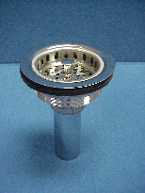

Tel: (860) 263-3635, Fax: (860) 229-4328

E-mail: sales@csbint.biz

41 Hammer Hill Road,
Rocky Hill, CT 06067

