
Specification Sheet

C.S.B. INTERNATIONAL PRODUCTS INC.

Short Basket, 1/8" Rubber Washer, Fiber Washer,
1 ½" Die Cast Lock Nut

Part Number | Size | Material
727SS | 2 – 2 ½" | All Stainless Steel

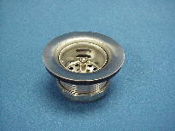

Tel: (860) 263-3635, Fax: (860) 229-4328

E-mail: sales@csbint.biz

41 Hammer Hill Road,
Rocky Hill, CT 06067

