
Specification Sheet

C.S.B. INTERNATIONAL PRODUCTS INC.
Stainless Steel Deep Basket Strainer

Part Number | Size | Finish | Material
728SS | 2"-2 ½" | ~ | Stainless Steel
728TSS For 4" Chrome Plated Tailpiece

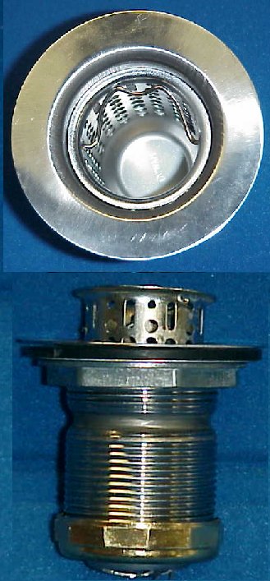

Tel: (860) 263-3635, Fax: (860) 229-4328

E-mail: sales@csbint.biz

41 Hammer Hill Road,
Rocky Hill, CT 06067

