
Specification Sheet

C.S.B. INTERNATIONAL PRODUCTS INC.

Stainless Steel Duplex Grid Strainer

Part Number | Size | Finish | Material
735SS | 2"-2 ½" | ~ | Stainless Steel

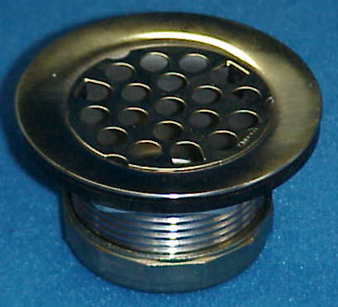

Tel: (860) 263-3635, Fax: (860) 229-4328

E-mail: sales@csbint.biz

41 Hammer Hill Road,
Rocky Hill, CT 06067

