
Specification Sheet

C.S.B. INTERNATIONAL PRODUCTS INC.

Strainer w/Locking Cup, Brass Shank & Cut Threads. Basket w/Rolled-Edge & Stick Post, ¼"Rubber Washer, ½" Die Cast Lock Nut

Part Number | Size | Material
760SS | 3 ½ - 4" | Stainless Steel
760TSS For 4" Chrome Plated Tailpiece

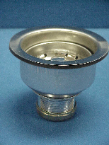

Tel: (860) 263-3635, Fax: (860) 229-4328

E-mail: sales@csbint.biz

41 Hammer Hill Road,
Rocky Hill, CT 06067

