
Specification Sheet

C.S.B. INTERNATIONAL PRODUCTS INC.

Ball Locking Post, ¼" Rubber Washer, Rolled Edge Basket

Part Number | Size | Material
768SS | 3 ½ - 4" | All Stainless Steel
768TSS For 4" Chrome Plated Tailpiece

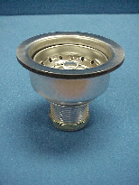

Tel: (860) 263-3635, Fax: (860) 229-4328

E-mail: sales@csbint.biz

41 Hammer Hill Road,
Rocky Hill, CT 06067

