
Specification Sheet

C.S.B. INTERNATIONAL PRODUCTS INC.

1 ½" Double End Straight Goods- Slip Joint

Part Number | Size | Finish | Material
806D-16CP | 1 ½ x 16" 22GA | Chrome Plated | Brass
3806D-16CP | 1 ½ x 16" 20GA | Chrome Plated | Brass
3806D-16RB | 1 ½ x 16" 20GA | Rough Brass | Brass

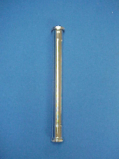

Tel: (860) 263-3635, Fax: (860) 229-4328

E-mail: sales@csbint.biz

41 Hammer Hill Road,
Rocky Hill, CT 06067

