
Specification Sheet

C.S.B. INTERNATIONAL PRODUCTS INC.

1 ¼" extension Tubes- Slip Joint w/Nut & Washer

Part Number | Size | Finish | Material
808-8CP | 1 ¼ x 8" 22GA | Chrome Plated | Brass
808-8RB | 1 ¼ x 8" 22GA | Rough Brass | Brass
3808-8CP | 1 ¼ x 8" 20GA | Chrome Plated | Brass
3808-8RB | 1 ¼ x 8" 20GA | Rough Brass | Brass
4808-8CP | 1 ¼ x 8" 17GA | Chrome Plated | Brass
4808-8RB | 1 ¼ x 8" 17GA | Rough Brass | Brass

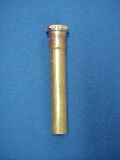

Tel: (860) 263-3635, Fax: (860) 229-4328

E-mail: sales@csbint.biz

41 Hammer Hill Road,
Rocky Hill, CT 06067

