
melmelm Specification Sheet

C.S.B. INTERNATIONAL PRODUCTS INC.

1 ½ x 4" Sink Tailpieces

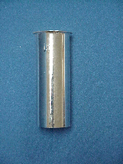
Part Number | GA | Finish | Material
812-4CP | 22GA | Chrome Plated | Brass
812-4RB | 22GA | Rough Brass | Brass
3812-4CP | 20GA | Chrome Plated | Brass
3812-4RB | 20GA | Rough Brass | Brass
4812-4CP | 17GA | Chrome Plated | Brass
4812-4RB | 17GA | Rough Brass | Brass

Tel: (860) 263-3635, Fax: (860) 229-4328

E-mail: sales@csbint.biz

41 Hammer Hill Road,
Rocky Hill, CT 06067

