
Specification Sheet

C.S.B. INTERNATIONAL PRODUCTS INC.

1 3/8" Threaded Both End Tubes

Part Number | Dim B, GA | Finish | Material
838-6CP | 6", 20GA | Chrome Plated | Brass
838-6RB | 6", 20GA | Rough Brass | Brass
838-8CP | 8", 20GA | Chrome Plated | Brass
838-8RB | 8", 20GA | Rough Brass | Brass
838-12CP | 12", 20GA | Chrome Plated | Brass
838-12RB | 12", 20GA | Rough Brass | Brass

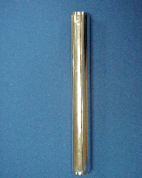

Tel: (860) 263-3635, Fax: (860) 229-4328

E-mail: sales@csbint.biz

41 Hammer Hill Road,
Rocky Hill, CT 06067

