
Specification Sheet

C.S.B. INTERNATIONAL PRODUCTS INC.

Slip Joint Dishwasher Branch Tailpieces
¾" Hose Thread & ½" Nom. Sweat

Part Number | Size | Finish | Material
850-8WRCP | 1 ½ x 8" 22GA | Chrome Plated | Brass
850-8WRRB | 1 ½ x 8" 22GA | Rough Brass | Brass
4850-8WRCP | 1 ½ x 8" 17GA | Chrome Plated | Brass
4850-8WRRB | 1 ½ x 8" 17GA | Rough Brass | Brass

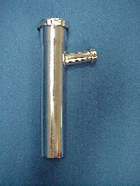

Tel: (860) 263-3635, Fax: (860) 229-4328

E-mail: sales@csbint.biz

206 Newington Avenue, P.O. Box 2380

New Britain, CT 06050

