
Specification Sheet

C.S.B. INTERNATIONAL PRODUCTS INC.

Slip Joint Dishwasher Branch Tailpieces
½" Nom. Sweat

Part Number | Size | Finish | Material
850A-8WRCP | 1 ½ x 8" 22GA | Chrome Plated | Brass
850A-8WRRB | 1 ½ x 8" 22GA | Rough Brass | Brass
4850A-8WRCP | 1 ½ x 8" 17GA | Chrome Plated | Brass
4850A-8WRRB | 1 ½ x 8" 17GA | Rough Brass | Brass

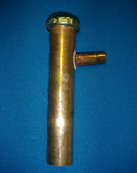

Tel: (860) 263-3635, Fax: (860) 229-4328

E-mail: sales@csbint.biz

41 Hammer Hill Road,
Rocky Hill, CT 06067

