Specification Sheet

The Connecticut Stamping & Bending Company

Dishwasher Long Branch Tailpiece

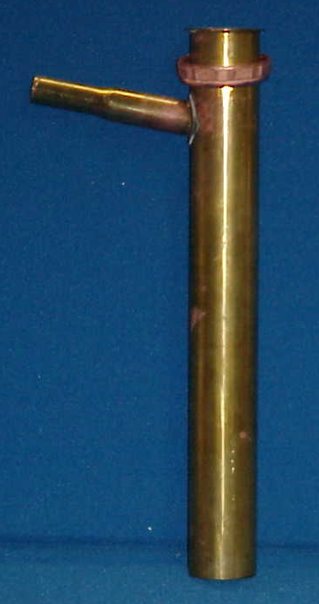
Part Number | Size | Finish | Material
852-12RB | 1 ½"x 12"22GA. | Rough Brass | Brass

Tel: (860) 263-3635, Fax: (860) 229-4328

E-mail: sales@csbint.biz

41 Hammer Hill Road,
Rocky Hill, CT 06067

