
Specification Sheet

C.S.B. INTERNATIONAL PRODUCTS INC.

1 ½" T.O.E. Dishwasher Branch Tailpieces

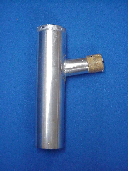
Part Number | Dim "A" | Finish | Material
855-6TOECP | 6" 22GA | Chrome Plated | Brass
855-6TOERB | 6" 22GA | Rough Brass | Brass
855-8TOECP | 8" 22GA | Chrome Plated | Brass
855-8TOERB | 8" 22GA | Rough Brass | Brass

Tel: (860) 263-3635, Fax: (860) 229-4328

E-mail: sales@csbint.biz

41 Hammer Hill Road,
Rocky Hill, CT 06067

