
Specification Sheet

C.S.B. INTERNATIONAL PRODUCTS INC.

1 ¼" T.O.E. Dishwasher Branch Tailpieces

Part Number | Size | Finish | Material
857-8TOECP | 1 ¼ x 8" 22GA | Chrome Plated | Brass
857-8TOERB | 1 ¼ x 8" 22GA | Rough Brass | Brass

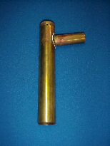

Tel: (860) 263-3635, Fax: (860) 229-4328

E-mail: sales@csbint.biz

41 Hammer Hill Road,
Rocky Hill, CT 06067

