
Specification Sheet

C.S.B. INTERNATIONAL PRODUCTS INC.

Straight Double Slip Repair Connections

Part Number | Size | Finish | Material
860CP | 1 ¼" | Chrome Plated | Brass

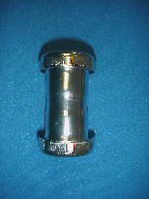

Tel: (860) 263-3635, Fax: (860) 229-4328

E-mail: sales@csbint.biz

41 Hammer Hill Road,
Rocky Hill, CT 06067

