
Specification Sheet

C.S.B. INTERNATIONAL PRODUCTS INC.

45 Degree Double Slip Joint Repair Connection

Part Number | Size | Finish | Material
863CP | 1 ½ x 1/ ½" | Chrome Plated | Brass

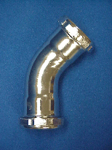

Tel: (860) 263-3635, Fax: (860) 229-4328

E-mail: sales@csbint.biz

41 Hammer Hill Road,
Rocky Hill, CT 06067

