
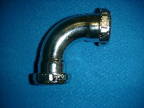Specification Sheet

C.S.B. INTERNATIONAL PRODUCTS INC.

90 Degree Double Slip Repair Connections

Part Number | Size | Finish | Material
866CP | 1 ½" | Chrome Plated | Brass

Tel: (860) 263-3635, Fax: (860) 229-4328

E-mail: sales@csbint.biz

41 Hammer Hill Road,
Rocky Hill, CT 06067

