
Specification Sheet

C.S.B. INTERNATIONAL PRODUCTS INC.

1 ¼" Semi-Cast P-Trap, W/ C/O, Polished Chrome

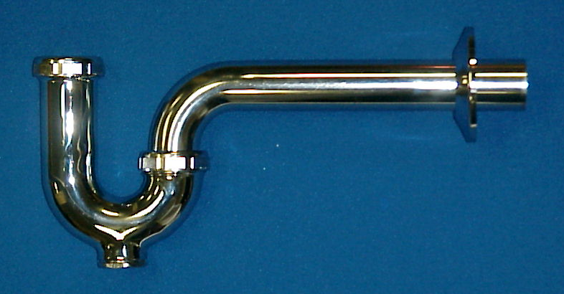
Part Number | Size | Finish | Material
95PC | 1 ¼" 20 GA. | PC | Brass
97PC | 1 ¼" 17 GA. | PC | Brass

Tel: (860) 263-3635, Fax: (860) 229-4328

E-mail: sales@csbint.biz

41 Hammer Hill Road,
Rocky Hill, CT 06067

